**Key Focus Areas:**

* Energy Management: HVAC, lighting, and appliance optimization.
* Water Conservation: Leak detection, irrigation, and usage tracking.
* Waste Reduction: Smart waste sorting, recycling, and landfill reduction.
* Transportation Efficiency: EV charging, shuttle route optimization, and parking management.
* Scalable framework

**System Architecture Overview**

Sensors/Data Sources → Data Processing Layer → AI Algorithms → Actions/Optimization → Dashboard/Reporting

**Architecture diagram (AI system view)**

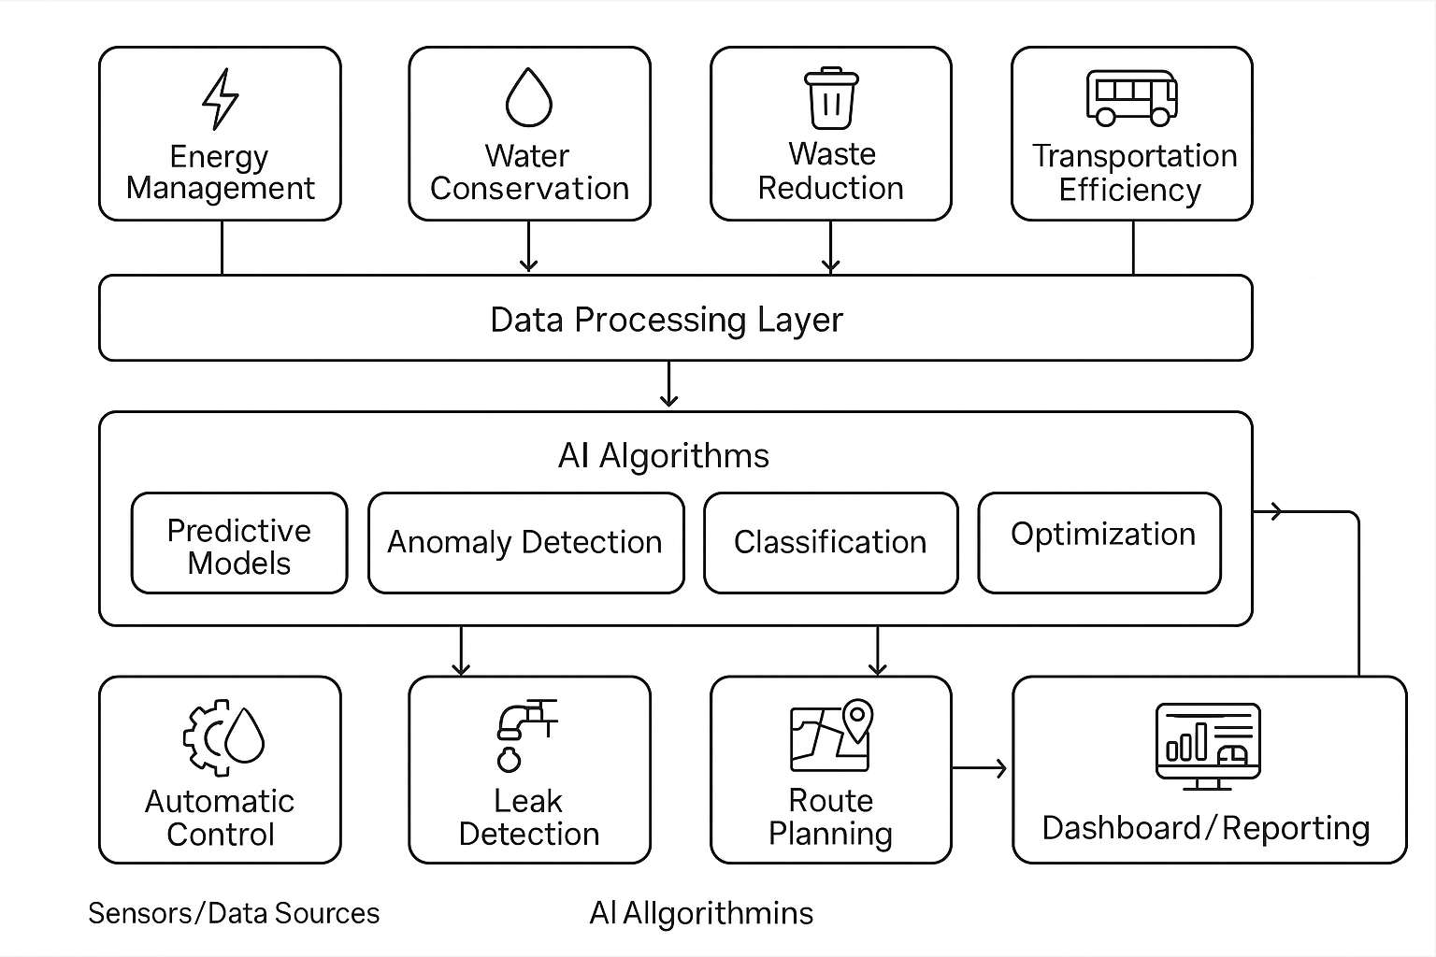

**Focus Area Breakdown (with Algorithms)**

1. **Energy Management**

**AI Techniques:**

|  |  |  |
| --- | --- | --- |
| **Task** | **Algorithm** | **Why** |
| Room usage prediction | LSTM / XGBoost | These algorithms predict room occupancy over time. LSTM handles time-series data (like hourly or daily usage), and XGBoost is great for structured data. |
| Energy anomaly detection | Isolation Forest | |  | | --- | |  |  |  | | --- | | Detects unusual energy usage patterns, such as spikes due to equipment faults or misuse. | |
| HVAC optimization | Deep Deterministic Policy Gradient (DDPG) | A deep reinforcement learning method used for continuous control systems, like adjusting heating/cooling levels smoothly. |
| Control optimization | Reinforcement Learning (Q-Learning) | Learns energy-saving actions over time. |

1. **Water Conservation**

**AI Techniques**

|  |  |  |
| --- | --- | --- |
| **Task** | **Algorithm** | **Why** |
| |  | | --- | | Leak detection |  |  | | --- | |  | | One-Class SVM / Autoencoder | |  | | --- | | Learns “normal” usage and flags anomalies. |  |  | | --- | |  | |
| Irrigation optimization | Decision Trees + Weather API | |  | | --- | |  |  |  | | --- | | Decision Trees can help decide when and how much to irrigate based on inputs like soil moisture, temperature, and weather forecasts. Integrating weather APIs helps avoid overwatering by skipping irrigation when rain is expected. | |
| |  | | --- | | Water Usage Forecasting |  |  | | --- | |  | | Linear Regression / LSTM | These models predict future water usage. Linear Regression works well for simple trends, while LSTM is better for complex, time-dependent usage patterns (like weekday vs. weekend patterns). This helps plan and avoid overconsumption. |
| High consumption zone prediction | Use K-means | Cluster common zone where water consumption is high. |

1. **Waste Reduction**

**AI Techniques:**

|  |  |  |
| --- | --- | --- |
| **Task** | **Algorithm** | **Why** |
| |  | | --- | | Waste classification (image) |  |  | | --- | |  | | CNN | |  | | --- | | Lightweight, real-time classification. |  |  | | --- | |  | |
| Fill-level prediction | Linear Regression | |  | | --- | |  |  |  |  |  | | --- | --- | --- | | |  | | --- | | Time-based estimation. |  |  | | --- | |  | | |
| |  | | --- | | Route optimization |  |  | | --- | |  | | Dijkstra’s / Genetic Algorithm | |  | | --- | | Efficient bin collection planning. | |

1. **Transportation Efficiency**

**AI Techniques**

| **Task** | **Algorithm** | **Why** |
| --- | --- | --- |
| Shuttle demand | Time Series Forecasting (ARIMA, LSTM) | Understand peak/off-peak demand. |
| Route optimization | A* / Reinforcement Learning | Learns best shuttle paths dynamically. |
| Parking prediction | K-Means + Heatmaps | Cluster common locations. |
| EV charging slot prediction | Logistic Regression / Queue Modeling | Predict station availability |